​

V Final Code

A Convolutional Neural Network (CNN) is a deep learning model used for image and signal processing, where convolutional and pooling operations are applied to input data to extract features and make predictions.​

​ ​ ​ ​ ​ ​ ​

​ What is a Convolutional Neural Network ?​

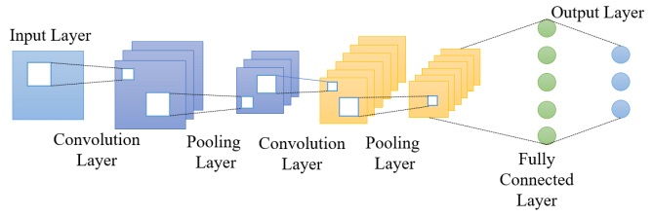

For Convolution layer with k filters of size f x f and the input channel of image c:

Total Parameter = k x (f x f x c_in) + k​ ​

For a Fully Connected layer with n neurons and number of input I:​

Total Paramenter = n x ( I + 1)​ ​

By calculating the number of parameters in each layer and summing them up, you can obtain the total number of parameters in the entire CNN.​ ​

​ ​ ​ ​ ​ ​

​ Number of parameter​ ​



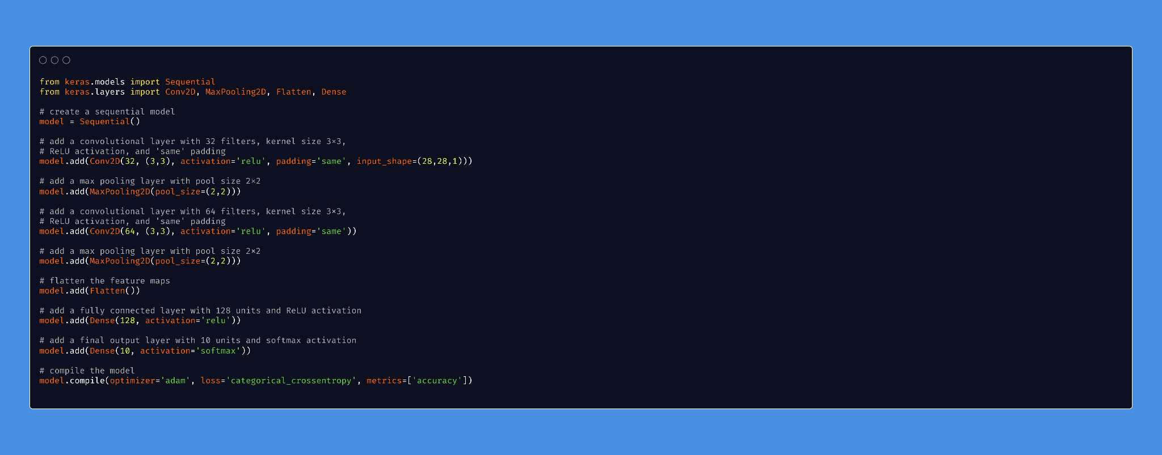

Global Average Pooling 2D is a type of pooling operation used in Convolutional Neural Networks (CNNs).

It takes the average of all feature maps in a given input and outputs a single value for each feature map, reducing the spatial dimensions of the feature maps.

This operation is useful for capturing the global spatial information of an input

while reducing the computational cost and overfitting.

Global Average Pooling

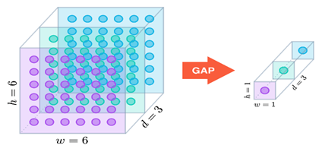

Loss Gradients

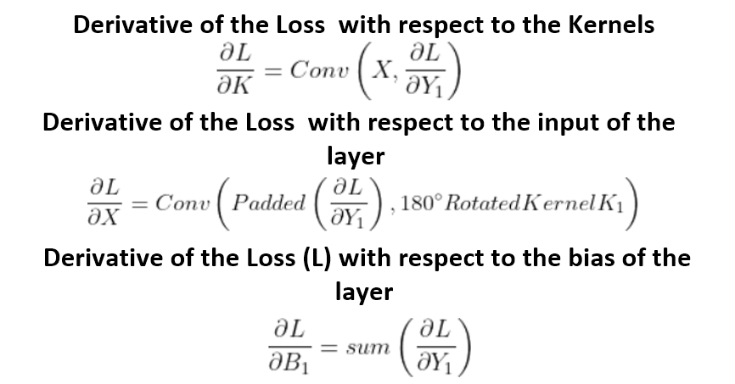

Log Loss Function

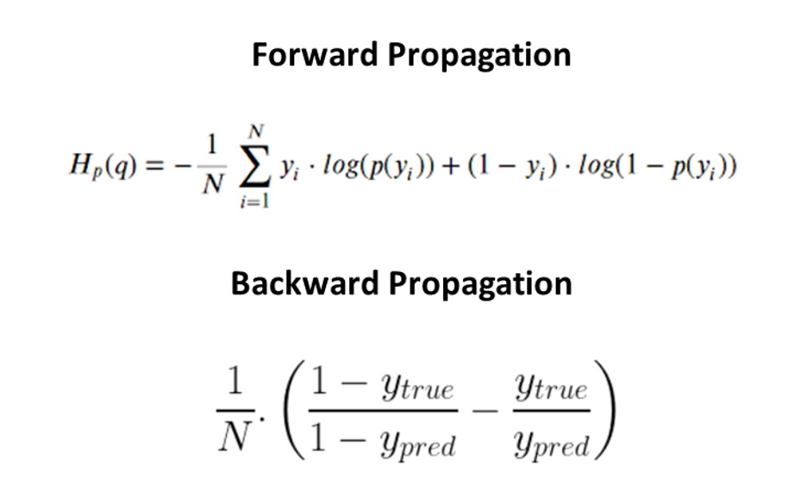

**VGG:**Large number of parameters: VGG has a large number of parameters, making it prone to overfitting and memory-intensive.

Computationally expensive: The use of small 3x3 filters results in a large number of operations and can be computationally expensive.

**AlexNet:**Limited representational capacity: AlexNet has a relatively shallow architecture with limited representational capacity, which can limit its ability to learn complex features and representations.

Over-reliance on data augmentation: AlexNet was heavily reliant on data augmentation techniques, such as image flipping and color shifting, which can be time-consuming and may not always be appropriate.

Drawbacks of VGG and AlexNet

Deeper architectures in Convolutional Neural Networks (CNNs) are needed to improve the performance of the network by allowing it to learn more complex representations of the data

.

A deeper network has more layers, and each layer can learn to extract a different and more abstract representation of the data.

This allows the network to learn increasingly complex features, such as shapes, textures, and patterns, that are important for image classification and other computer vision tasks.

Why do we need Deeper Architecture?

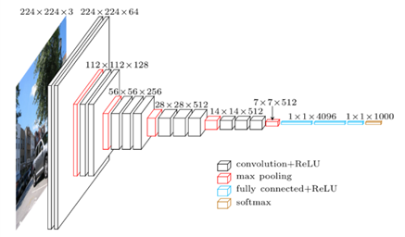

**ResNet:**

**Residual connections**: ResNet introduced the concept of residual connections, which allow the network to learn residual representations instead of direct representations.

This helps prevent vanishing gradients and enables the network to train deeper models without degradation in performance.

Improved representational capacity: ResNet has a much deeper architecture than VGG and AlexNet, which allows it to learn more complex representations.

**Inception:**

**Improved efficiency**: The Inception architecture uses multiple parallel branches with different filter sizes and concatenates the results, which allows the network to learn multiple scales of features efficiently.

Reduced number of parameters: Inception uses multiple smaller filters instead of a few large filters, which reduces the number of parameters and reduces the risk of overfitting.

How ResNet and Inception better than AlexNet and VGG?

Skip connections in Convolutional Neural Networks (CNNs) are connections that bypass one or more layers in the network, allowing the gradients to flow more easily through the network during training.

The idea behind skip connections is to mitigate the vanishing gradient problem, which can occur in very deep networks and cause the gradients to become very small, making training difficult.

Skip connections allow the activations from earlier layers to be combined with the activations from later layers, allowing the network to maintain a stronger gradient signal throughout the network.

This can help to improve the training process and allow the network to learn more complex features.

What are Skip connections?

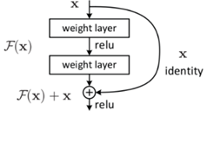

Vanishing Gradient

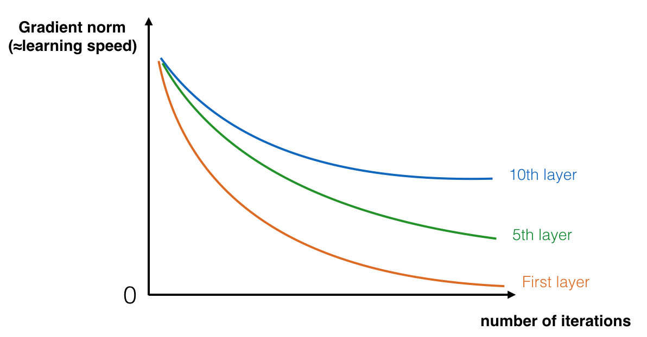

The speed of learning decreases very rapidly for the early layers as the network trains

ResNet50 Architecture

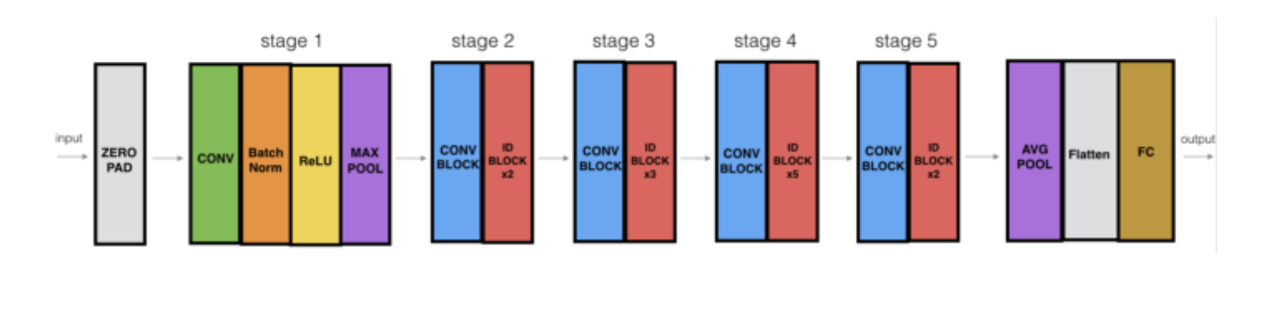

Skip connections in Convolutional Neural Networks (CNNs) are connections that bypass one or more layers in the network, allowing the gradients to flow more easily through the network during training.

The idea behind skip connections is to mitigate the vanishing gradient problem, which can occur in very deep networks and cause the gradients to become very small, making training difficult.

Skip connections allow the activations from earlier layers to be combined with the activations from later layers, allowing the network to maintain a stronger gradient signal throughout the network.

This can help to improve the training process and allow the network to learn more complex features.

What are Skip connections?



We use multiple levels of Feature Extraction in CNN because At lower levels, the network extracts simple features such as edges and corners, which are combined to form higher-level features such as textures and shapes.

These higher-level features are then combined to form even higher-level representations such as object parts and eventually complete objects.

By using multiple levels of feature extraction, the network can learn to recognize objects and their relationships from a wide range of viewpoints and scales.

Why do we need Multi-level Feature Extractor?

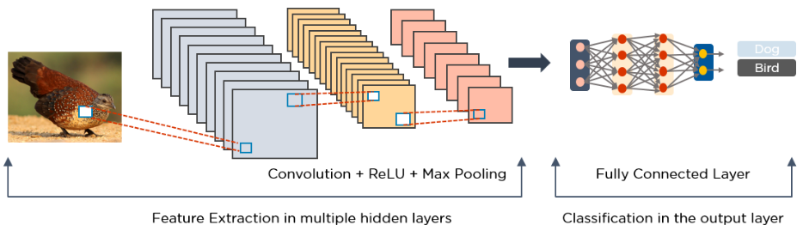

GoogleNet (Inception) Architecture

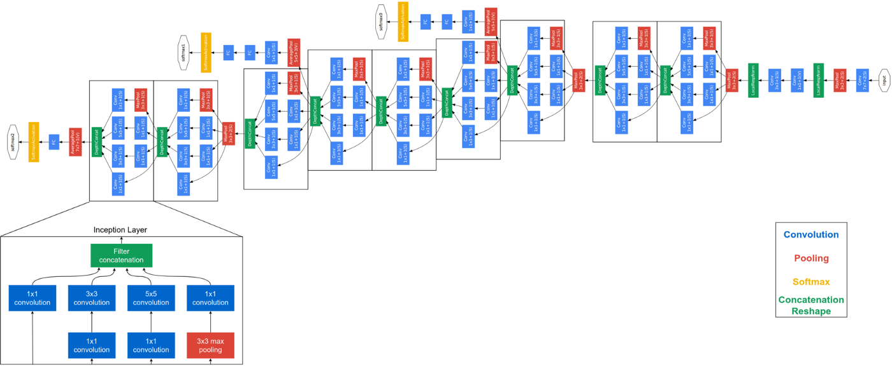

Architecture of Inception Module

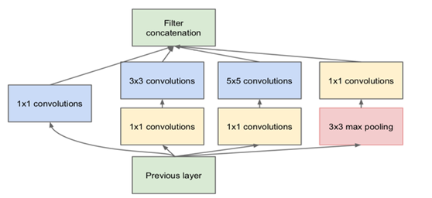

Code for Inception Module

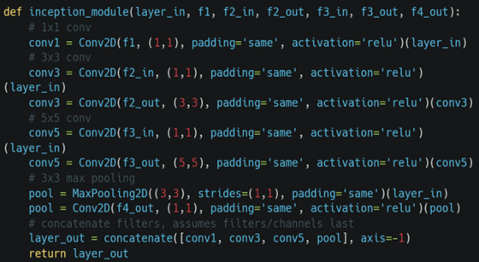

L6: CNN For Medical Diagnosis Cheat Sheet

Code for ResNet

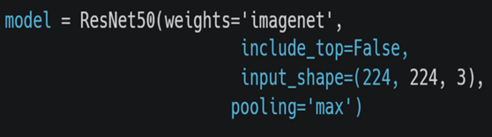

MobileNet is a CNN architecture that is much faster and smaller. These models are useful to be implemented on mobile and embedded devices.

MobileNet is known to give good results while being computationally inexpensive comparatively.

It was the first CNN architecture to use pointwise convolutions. It makes use of a new kind of convolutional layer, known as Depthwise-Separable convolution.

It has 10x less parameters compared to ResNet50 and still offer great results !

What is MobileNet?

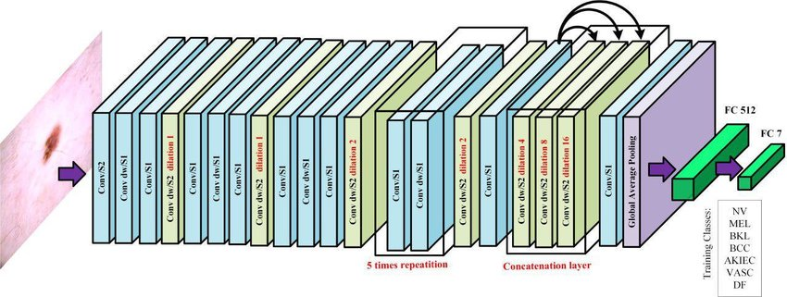

In Depthwise Convolution, we apply a single convolutional filter for each input channel

What is Depthwise Convolution?

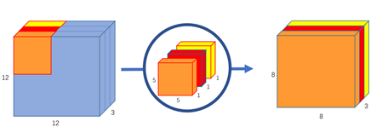

EfficientNet is a state-of-the-art CNN architecture which outperforms all previous ones while using lesser parameters.

It is actually a family of neural networks of different sizes, where a lot of attention was paid to the scaling of the networks in the family.

It uses a method that uniformly scales all dimensions of depth/width/resolution using a technique called compound coefficient.

It has eight models(B0->B7), with increasing size

What is EfficientNet?

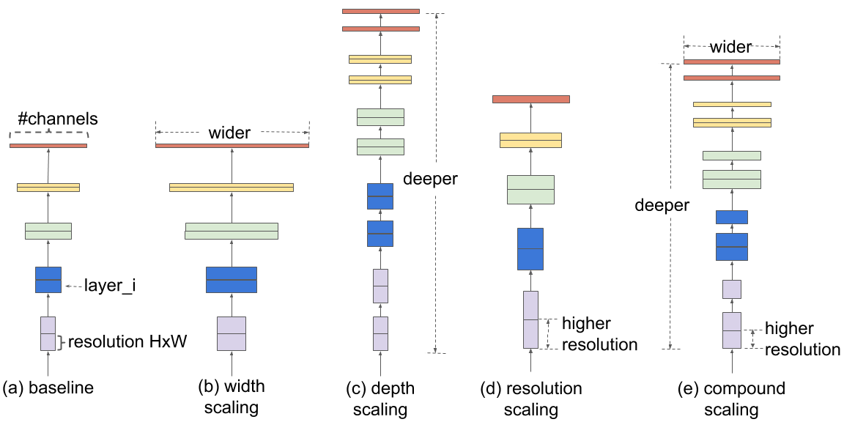

Depthwise Separable Convolution splits the computation into two steps:

**Depthwise convolution** : It applies a single convolutional filter per each input channel.

**Pointwise convolution**: It is used to create a linear combination of the output of the depthwise convolution.

What is Depthwise-Separable Convolution?

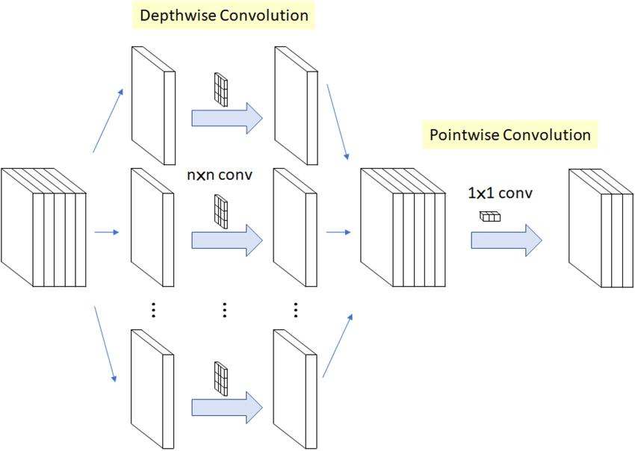

In Pointwise Convolution, we use a 1x1 kernel, which iterates across each and every point. This kernel has a depth equal to the number of channels in the input picture.

What is Pointwise Convolution?

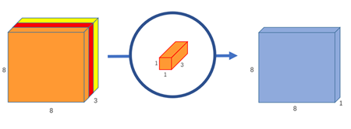

**Size of the new dataset**

**Similarity of new dataset with the original dataset**

New Dataset is small and similar : Fine-tuning might lead to overfitting.

New Dataset is large and similar : Fine-tune the pre-trained network

New Dataset is large and different : Train a Conv. Network from scratch

Factors to consider while using Transfer Learning



L7 : Object Detection with Two Stage Methods​ Cheat Sheet

Comparison of EfficientNet with other famous CNN Models

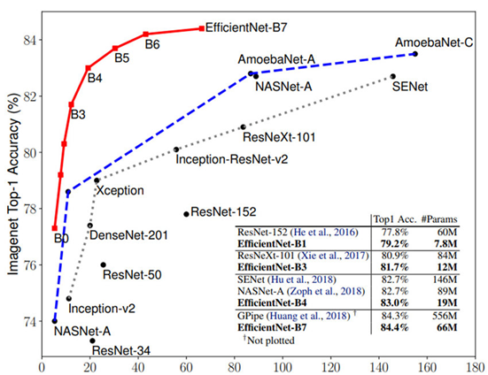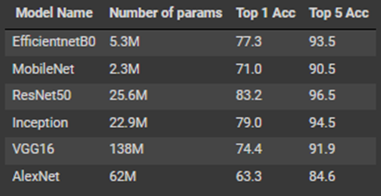

Object detection is a computer vision task to locate and identify objects in an image or video.​

It answers the following question:​

Where is the object of interest present in the Image?​

How many objects are present in Image?

​ ​ ​ ​ ​ ​ ​

​ What is Object Detection?​ ​

**​ ​**

​ ​ ​ ​ ​ ​ ​

​ Classification + Localization​

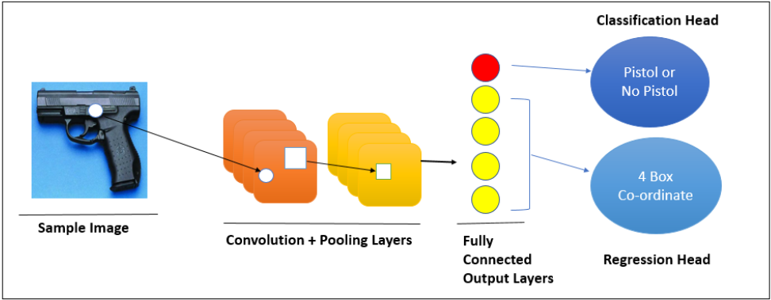

​ Model Configurations and Loss function mappings:​ ​

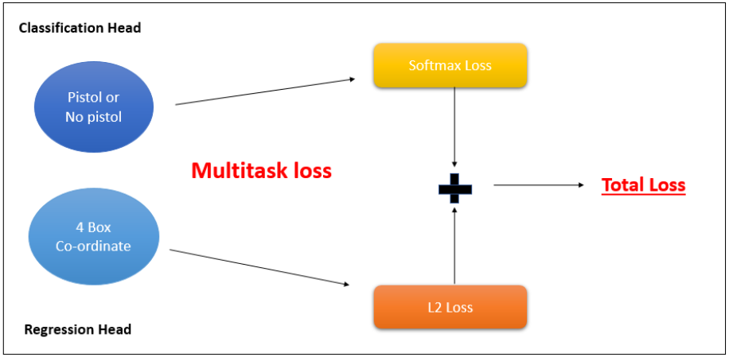

What is Sliding Window Detection?

Sliding window algorithm in CNN is a technique where a small window of fixed size is slid over the image to extract features and make predictions on a region of interest.​

IoU stands for Intersection over Union, which is a commonly used evaluation metric for object detection tasks.​

Typically, an IoU threshold is set, such as 0.5, and a prediction is considered a true positive if the IoU score is greater than or equal to the threshold.​

​ ​ ​ ​ ​ ​ ​

​ Introducing IoU as BBox Evaluation Metric​ ​

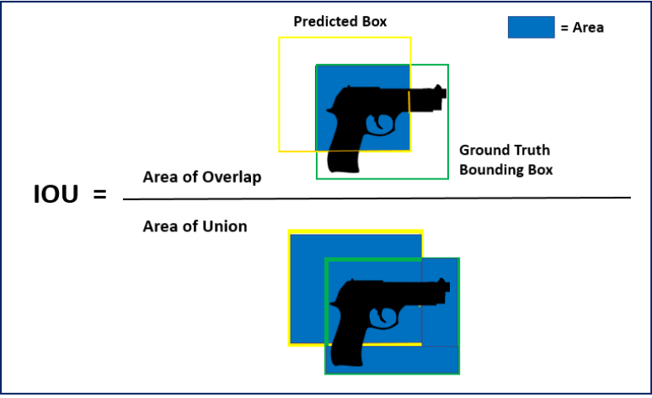



​ ​ Introduce NMS to Suppress BBOXES​ ​ ​

NMS (Non-Maxima Suppression) is a technique used to suppress redundant bounding boxes (BBOXES) in object detection algorithms in computer vision. ​

It works by keeping only the bounding box with the highest confidence score and removing other overlapping boxes, reducing the number of false positive detections.​

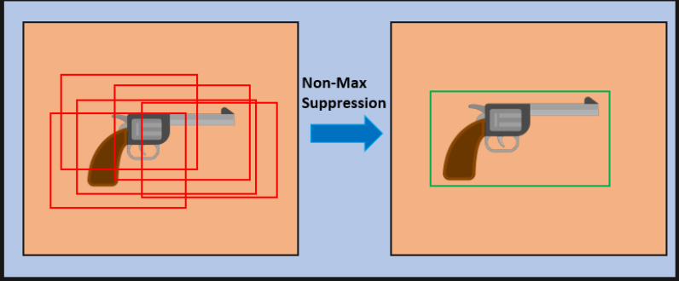

ROI (Region of Interest) pooling is a technique used in computer vision and deep learning for object detection and classification.​

It works by dividing the input image into regions of interest and then resizing each region to a fixed size, allowing the network to process each region independently and efficiently. ​

ROI pooling reduces the spatial dimensionality of the features, making it easier for the network to extract meaningful information from each region and make predictions.​

This technique helps improve the performance of object detection algorithms and makes them computationally more efficient.​

​ ​ What is ROI Pooling ?​ ​ ​

​ ​ Introducing TWO STAGE DETECTOR​ ​

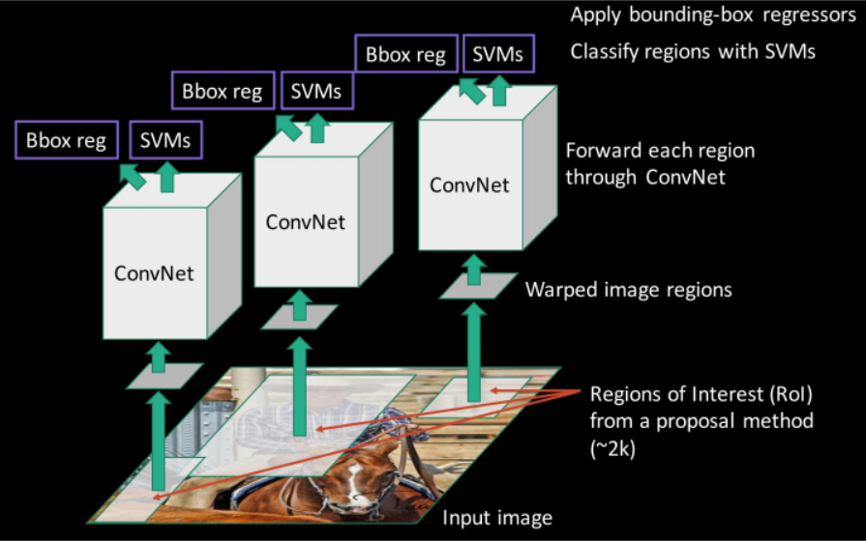

RCNN

RPN in R-CNN is a component that generates candidate object regions in an image by using a sliding window approach and outputting anchor boxes with objectness scores.

The RPN helps speed up object detection by reducing the number of region proposals processed by the classifier and by providing high-quality proposals for objects of different shapes

​ ​ ​ ​ ​ ​ ​

​ ​ What is RPN ?​ ​ ​

2. Fast RCNN

Instead of extracting features from each region proposal independently, Fast RCNN uses a shared convolutional layer to extract features from the entire image, reducing the number of computations needed.​

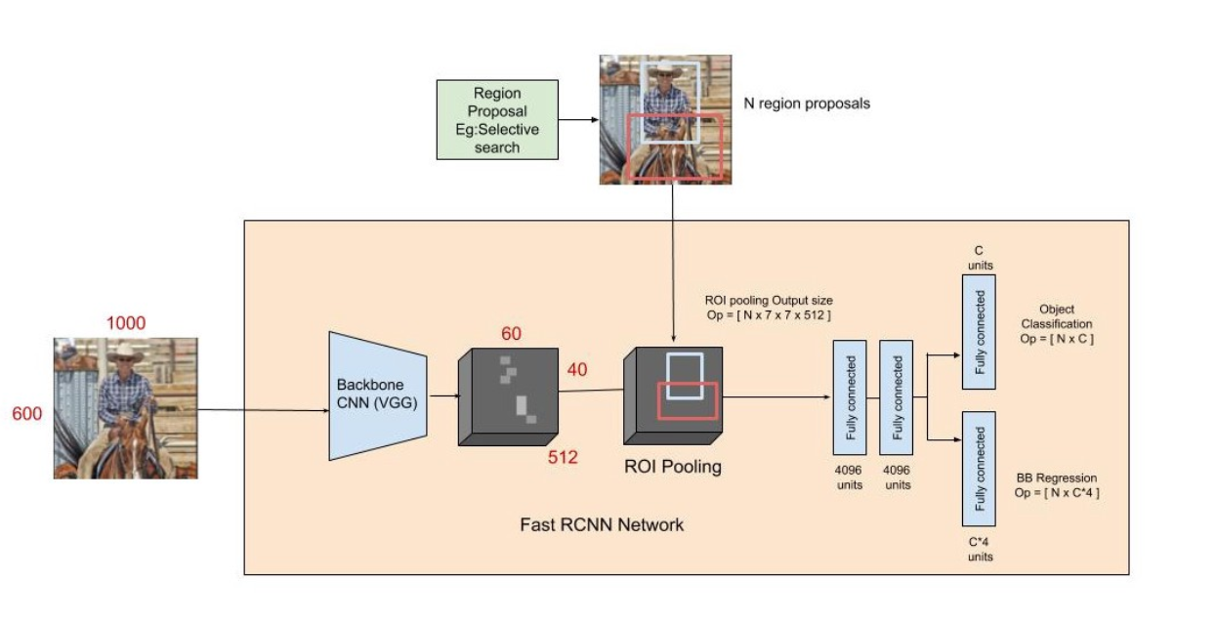

3. Faster RCNN

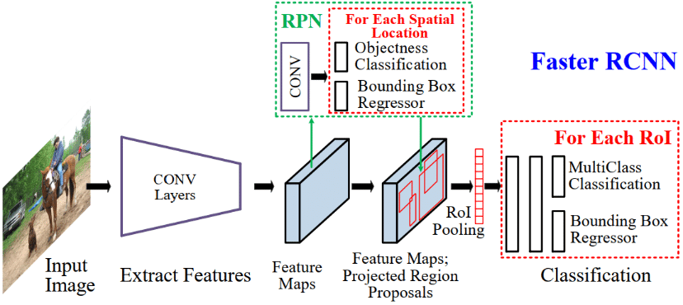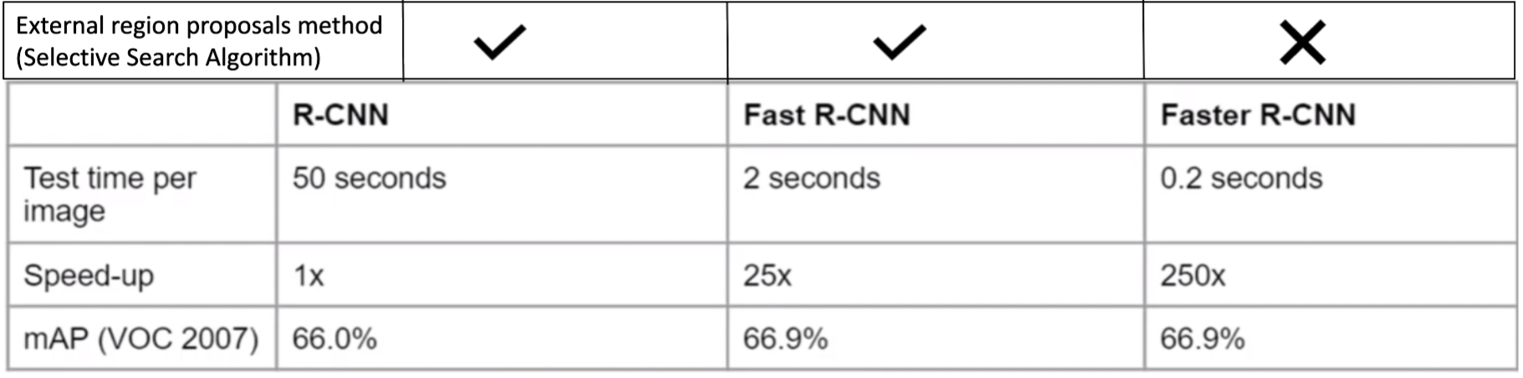

​ ​ ​ Comparison of Speed and mAP metric​ ​ ​ ​



L8: Object Detection With Single Stage Methods Cheat Sheet

**Computational cost**: R-CNN is computationally expensive, with a slow inference time due to its two-stage architecture.

**Poor recall**: R-CNN has poor recall performance, meaning it can miss object detections, particularly for smaller or occluded objects.

**Inefficient proposal generation**: R-CNN uses selective search to generate object proposals, which is slow and does not scale well with the size of the input image.

**Limited versatility**: R-CNN is designed to handle a limited set of object categories and may not perform well on new or unseen categories.

**Difficult to fine-tune**: R-CNN can be difficult to fine-tune for specific tasks, particularly when the training data is limited or difficult to obtain.

**Limited scalability**: Scaling up the size of an R-CNN model to handle a large number of object categories can be challenging, leading to slower inference speed and increased memory usage.

Problems With RCNN

Single Shot MultiBox Detector (SSD) is a one-stage object detection method that predicts class labels and bounding boxes for objects within an image.

It's an efficient alternative to two-stage object detectors, such as R-CNN, and is designed to handle a large number of object categories in real-time.

Single Shot Detector (SSD)

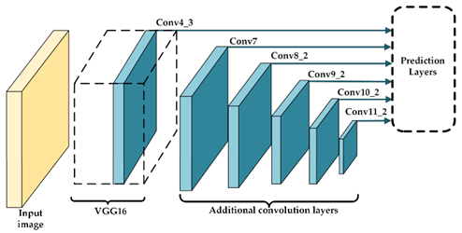

Single Shot MultiBox Detector (SSD) is an object detection method that uses multiple feature maps from different layers of a convolutional neural network (CNN) with a predictive head to predict class labels and bounding boxes for objects within an image.

It uses anchor boxes, or prior boxes, and a multi-task loss function to handle objects at different scales, shapes, and locations in a single forward pass.

This allows for fast and efficient object detection.

How SSD Works?

Single Stage VS Two-Stage Methods

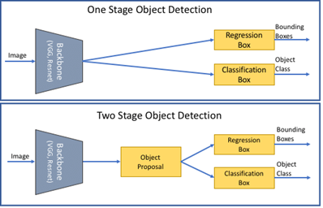

You Only Look Once (YOLO) is a one-stage object detection method that predicts class labels and bounding boxes for objects within an image.

It's designed to handle a large number of object categories in real-time and is known for its fast inference time and efficient use of computational resources.

You Only Look Once (YOLO)

How YOLO Works?

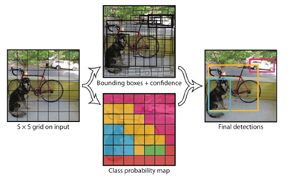

The bounding box contains four values: x, y, w, h, (x, y) represents the center of the box. (W, h) defines the width and height of the box.

Confidence indicates the probability of containing objects in this prediction box, which is the IoU value between the prediction box and the actual box.

The class probability indicates the class probability of the object, and the YOLOv3 uses a two-class method

Simple YOLO Architecture

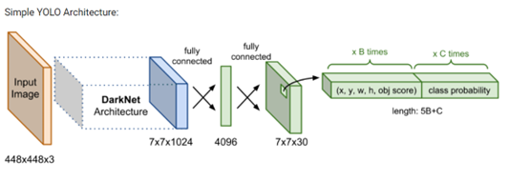

Both one stage detection methods, like SSD and YOLO evaluate almost 10^4 to 10^5 candidate locations per image.

But only a few locations contain objects (i.e. Foreground) and rest are just background objects.

This leads to class **imbalance problem**.

Small objects and close-by objects may be missed by YOLO like algorithms

YOLO can only detect a limited number of objects per image, making it less suitable for applications where a large number of objects need to be detected.

Drawbacks Of YOLO

RetinaNet is considered to be better than single stage object detection methods for several reasons:

**Better accuracy**: RetinaNet was designed to address the problem of class imbalance in object detection, where a large number of negative examples (i.e., background) can overwhelm the network and lead to poor performance.

RetinaNet addresses this by using a two-stage approach that uses a class-specific confidence score to filter out false positive detections.

**Faster inference**: Single stage object detectors such as YOLO and SSD use anchor boxes to detect objects and can generate multiple detections per object.

RetinaNet, on the other hand, generates only one detection per object, which results in faster inference times.

RetinaNet

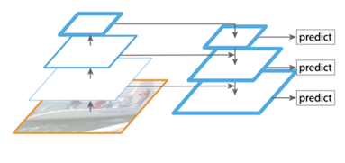

L9 : Object Segmentation CheatSheet

Image segmentation is the process of classifying each pixel in the image as belonging to a specific category.​ ​

Semantic segmentation : We treats multiple objects within a single category as one entity​

Instance segmentation : We identify individual objects within these categories​ ​

​ ​ ​ ​ ​ ​ ​

What is Object Segmentation ?​

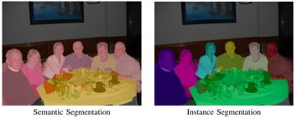

Transposed Convolutions is a method to up-sample the output. It can be considered as an opposite process to any simple CNN.​

Output Shape:

​ ​ ​ ​ ​ ​ ​

Transposed Convolution​



Code Sample for transposed convolution​

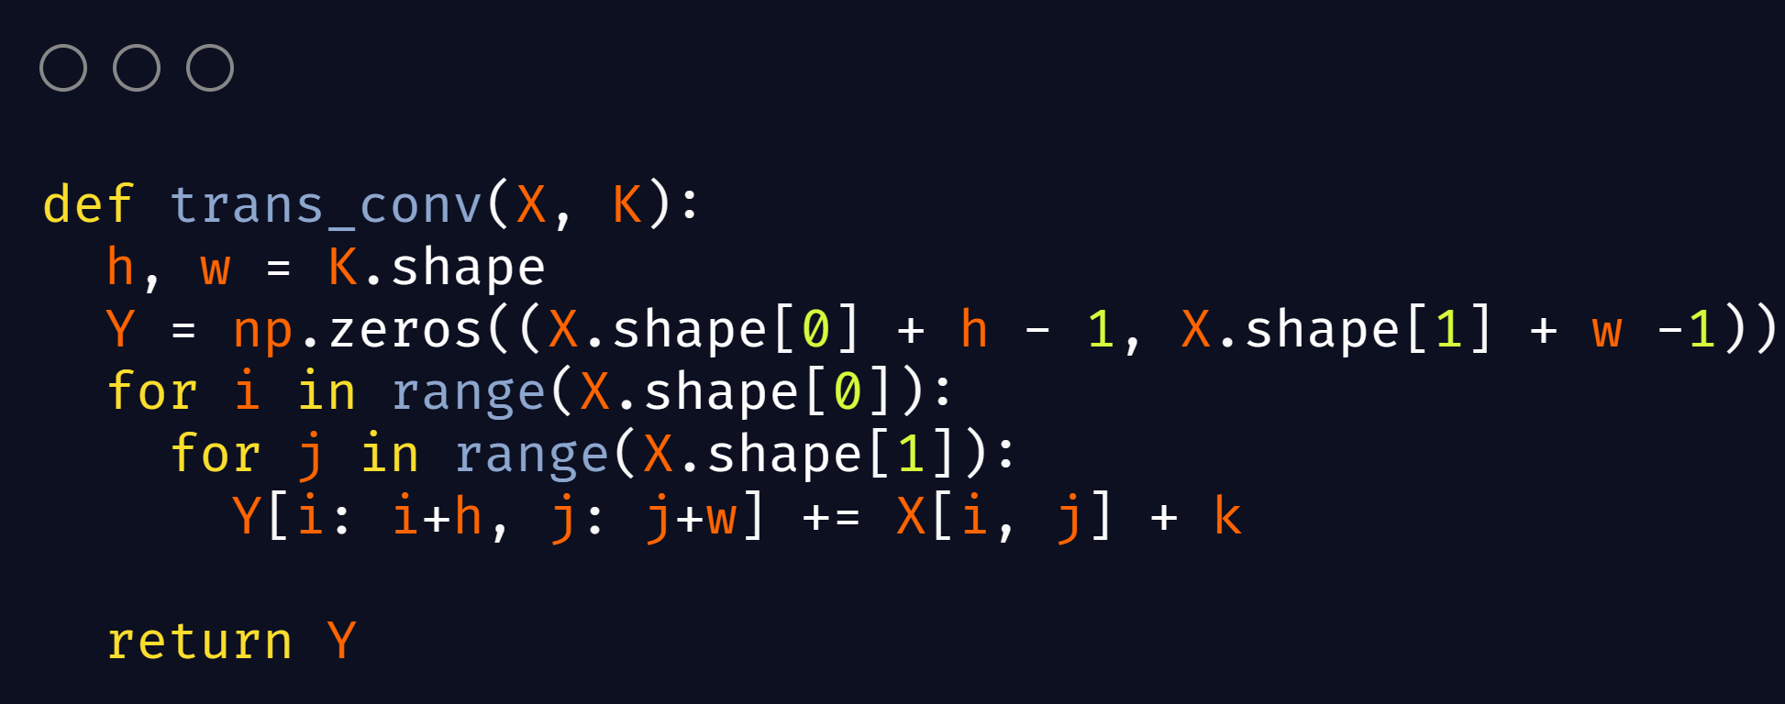

​ ​ ​ ​ ​ ​ ​

Intersection over Union

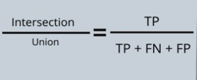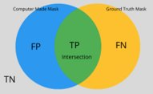

​ ​ ​ ​ ​ ​ ​

Dice Coefficient​

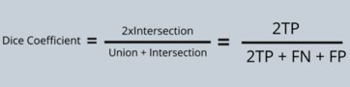

​ ​ ​ ​ ​ ​ ​

Encoder-Decoder Network​

Encoder-Decoder Network is an architecture consisting of two parts, an encoder that compresses input into a lower dimensional representation, and a decoder that reconstructs the output from the encoded representation.​

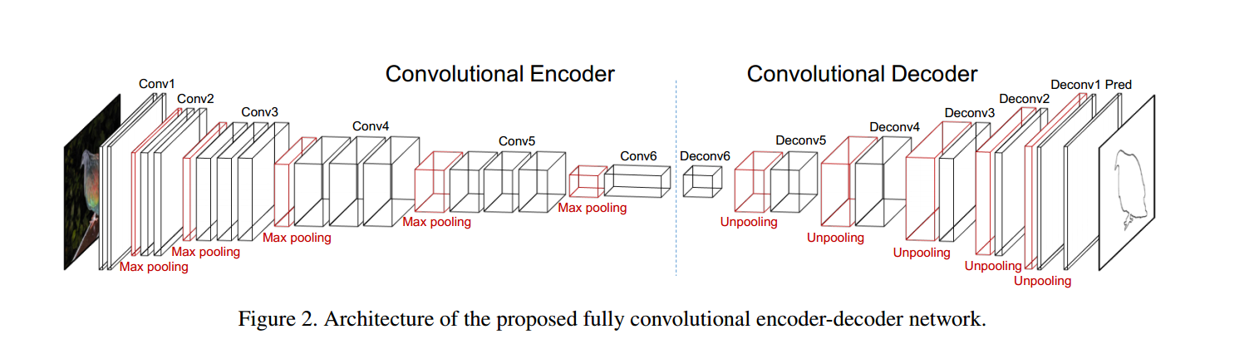

​ ​ ​ ​ ​ ​ ​

Mask R-CNN Architecture​ - 2

The FC layers predict the class labels and object masks using the features from the RoIAlign layer.​ ​

The mask branch uses a similar architecture to the fc layers, but with a transposed convolution layer at the end to upsample the mask predictions to the original image size.​

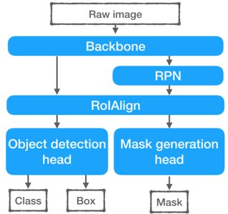

Fig: Mask R-CNN

Mask R-CNN Architecture​

Mask R-CNN is an extension of Faster R-CNN​ ​

The only new part is the mask generation head which is a fully Convolutional Head that upsamples to predict the mask​ ​

The remaining parts: backbone, a Region Proposal Network (RPN), a Region of Interest alignment layer (RoIAlign), a bounding-box object detection head are the same components as the Faster R-CNN in object detection.​ ​

The backbone feature extractor can be any convolutional neural network (CNN) trained on large image datasets, such as ResNet.​ ​

The RPN generates object proposals by sliding a small network across the feature maps and predicting object scores and bounding box coordinates.​ ​

The RoIAlign layer resamples the features from the object proposals to a fixed size to ensure that they have the same dimensions and can be processed by the fc layers.​ ​ ​

What is Object UpSampling2D ?​

UpSampling2D is a simple scaling up of images by using nearest neighbour or bilinear upsampling.​ ​

It is a cheap operation than Conv2DTranspose due to less involvement of parameters to be learnt by the model and makes the model less memory intensive which helps it to be used in Mobile devices.​ ​

Unet uses UpSampling2D() layers​ ​ ​​

U-Net Architecture​

U-net Model has a “U” shape architecture with a symmetric Encoder and Decoder.​

It uses Skip Connections between layers of Encoder and Decoder are used to make the information loss as minimal as possible.​

The final output layer produces a per-pixel prediction of the target mask or segmentation.​

U-Net is commonly used for image segmentation tasks, such as medical image analysis and computer vision applications.​ ​ ​

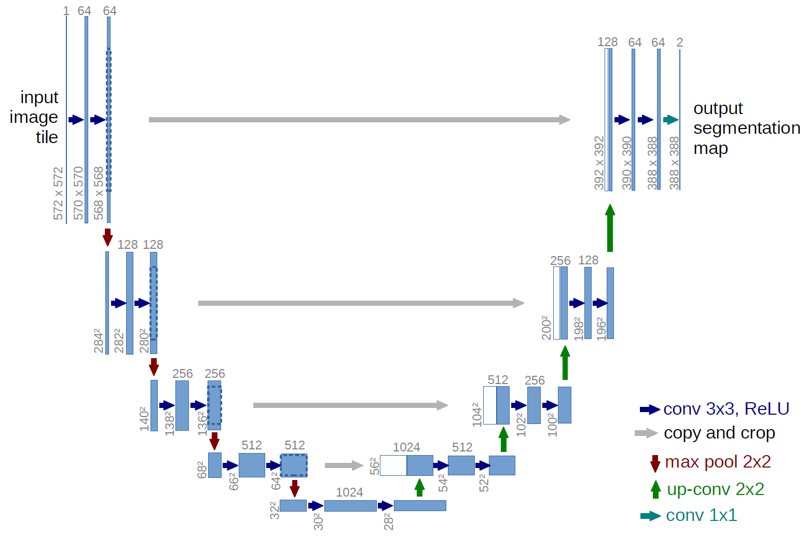

​ ​ ​ ​ ​ ​ ​

What is Atrous Convolution ?​

For each location i on the output y and a filter w, atrous convolution is applied over the input feature map x where the atrous rate r corresponds to the stride with which we sample the input signal.​ ​

This is equivalent to convolving the input x with upsampled filters produced by inserting r-1 zeros between two consecutive filter values along each spatial dimension.​ ​

When r=1, it is standard convolution.​ ​

By adjusting r, we can adaptively modify filter’s field-of-view.​ ​

It is also called dilated convolution.​ ​

Helps to have a border perspective of the image with the same number of parameters as the Standard Convolution layer​ ​ ​ ​

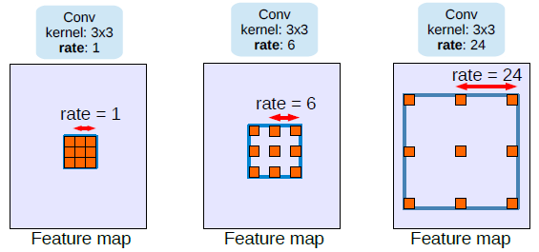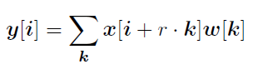

Atrous convolution with different rates

Atrous convolution formula



L10: Signature Verification Using Siamese Network Cheat Sheet

A Siamese Network is a type of neural network architecture that uses two or more identical sub-networks to process input data.

These sub-networks have the same architecture and parameters and are used to extract features from the input data.

The outputs of the sub-networks are then compared to perform a specific task, such as similarity measurement or verification.

The Siamese Network is commonly used in tasks such as face recognition and signature verification.

What is a Siamese Network?

The contrastive loss function takes as input two feature representations (embeddings) of a pair of data samples, such as two images, and a binary label indicating whether the pair is similar or dissimilar.

The contrastive loss then computes the Euclidean distance between the embeddings and applies a penalty based on the label.

If the pair is similar, the loss function encourages the embeddings to be close together. If the pair is dissimilar, the loss function encourages the embeddings to be far apart.

The contrastive loss helps the Siamese Network learn a discriminative embedding space, where similar inputs are close together and dissimilar inputs are far apart. This enables the network to perform tasks such as similarity measurement, one-shot learning, and verification more accurately.

Contrastive Loss

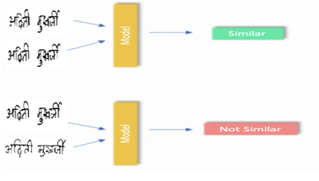

Architecture of Siamese Network

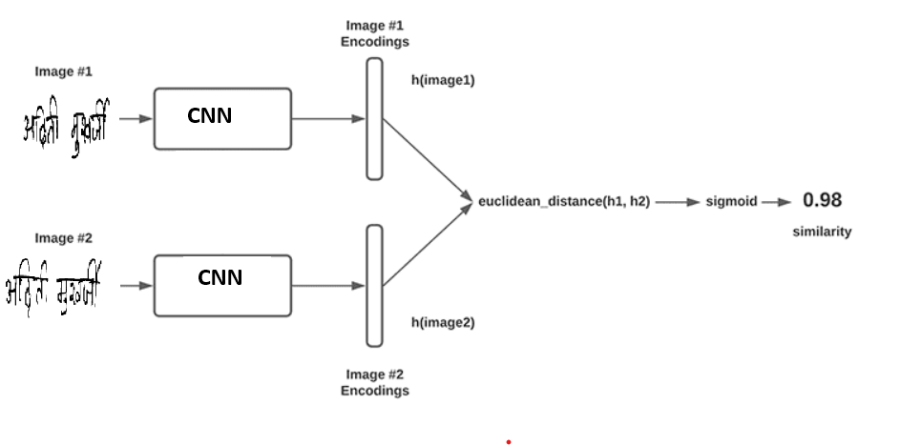

Contrastive Loss Eqution

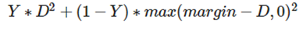

The Y value is our label. It will be 1 if the image pairs are of the same class, and it will be 0 if the image pairs are of a different class.

The D variable is the Euclidean distance between the outputs of the sister network embeddings.

The max function takes the largest value of 0 and the margin, m, minus the distance.

Embeddings Before and After Contrastive Loss

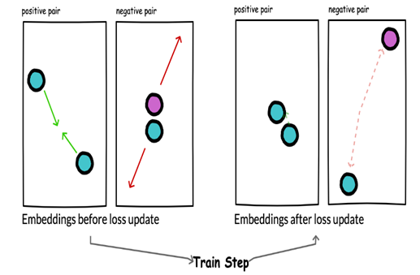

A triplet consists of three data samples: an anchor, a positive sample, and a negative sample. The anchor and positive samples are similar, while the anchor and negative samples are dissimilar.

The triplet loss function takes as input the feature representations (embeddings) of the anchor, positive, and negative samples and minimizes the difference between the distances of the anchor-positive and anchor-negative pairs.

In other words, the loss function encourages the network to produce embeddings such that the distance between the anchor and positive sample is smaller than the distance between the anchor and negative sample by a margin.

Triplet Loss

Triplet Loss Equation



d(A,P) is anchor-to-positive-distance and d(A,N) is anchor-to-negative-distance and α is the margin

Code for Contrastive Loss

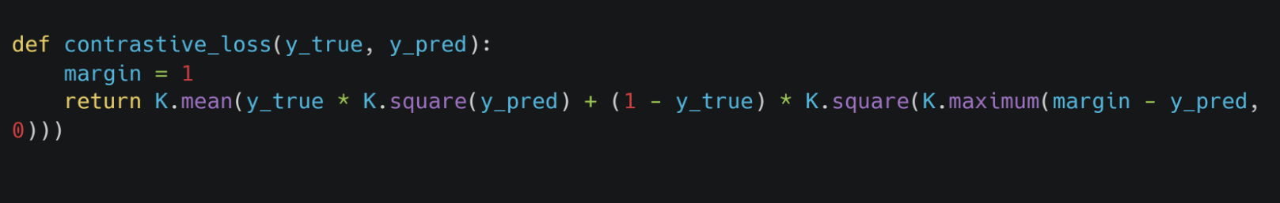

Triplet Loss

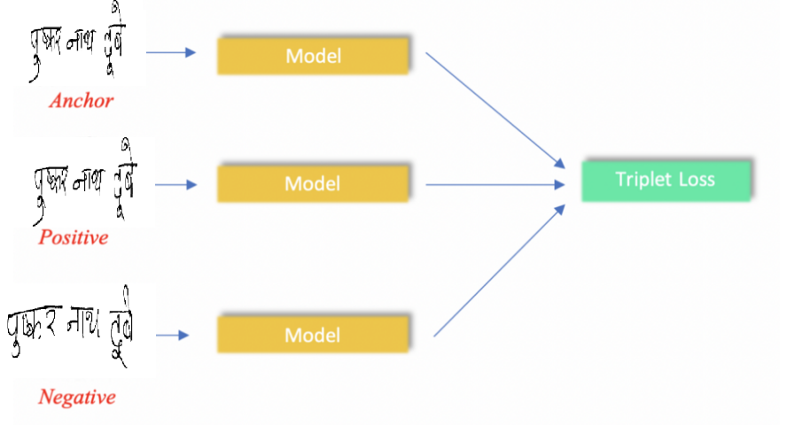

Embeddings Before and After Triplet Loss

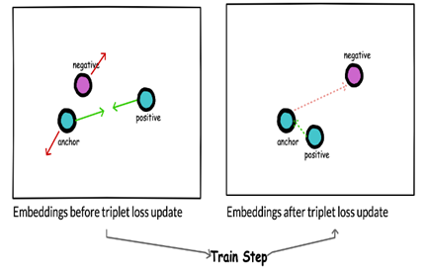

**Easy triplets**: result when d(A,N)>d(A,P)+α. Here, the sampled anchor-to-negative distance is already large enough so loss is 0, and the network has nothing to learn from.

**Hard triplets**: result when d(A,N)<d(A,P). In this case, the anchor-to-negative distance is less than the anchor-to-positive distance, meaning high loss to backpropagation through the network.

**Semi-hard triplets**: result when d(A,P)<d(A,N)<d(A,P)+α. Semi-hard triplets occur when the negative example is more distant to the anchor than the positive example, but the distance is not greater than the margin. This, therefore, results in a positive loss (i.e., the negative is far … but not far enough.)

Types of Triplet Mining

Code for Triplet Loss

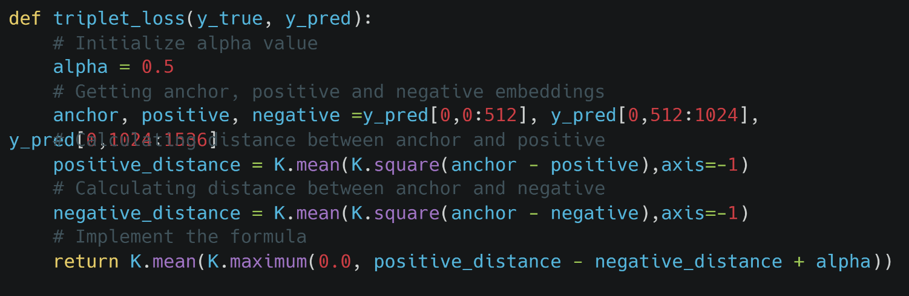

Triplet Mining

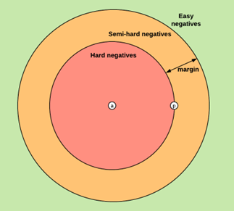

Lossless Triplet Loss

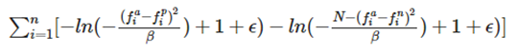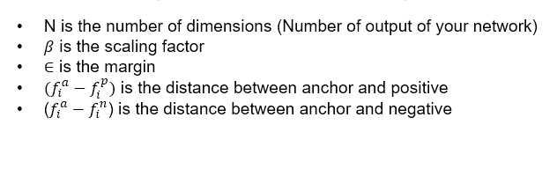

L11 : Introduction to GANs​ Cheat Sheet

\\

Generative Adversarial Networks (GANs) are a type of deep learning architecture that uses two neural networks, a generator and a discriminator, to generate new data samples that are similar to a training set.​

The generator network creates new data samples while the discriminator network evaluates the generated samples and determines whether they are similar to the real training data. This interaction between the two networks leads to the generator improving its ability to generate realistic data samples over time.​ ​ ​ ​ ​ ​

​ ​ ​ ​ ​ ​ ​

​ What are GANs?​ ​

​ ​ ​ ​ ​ ​ ​

Architecture of GANs

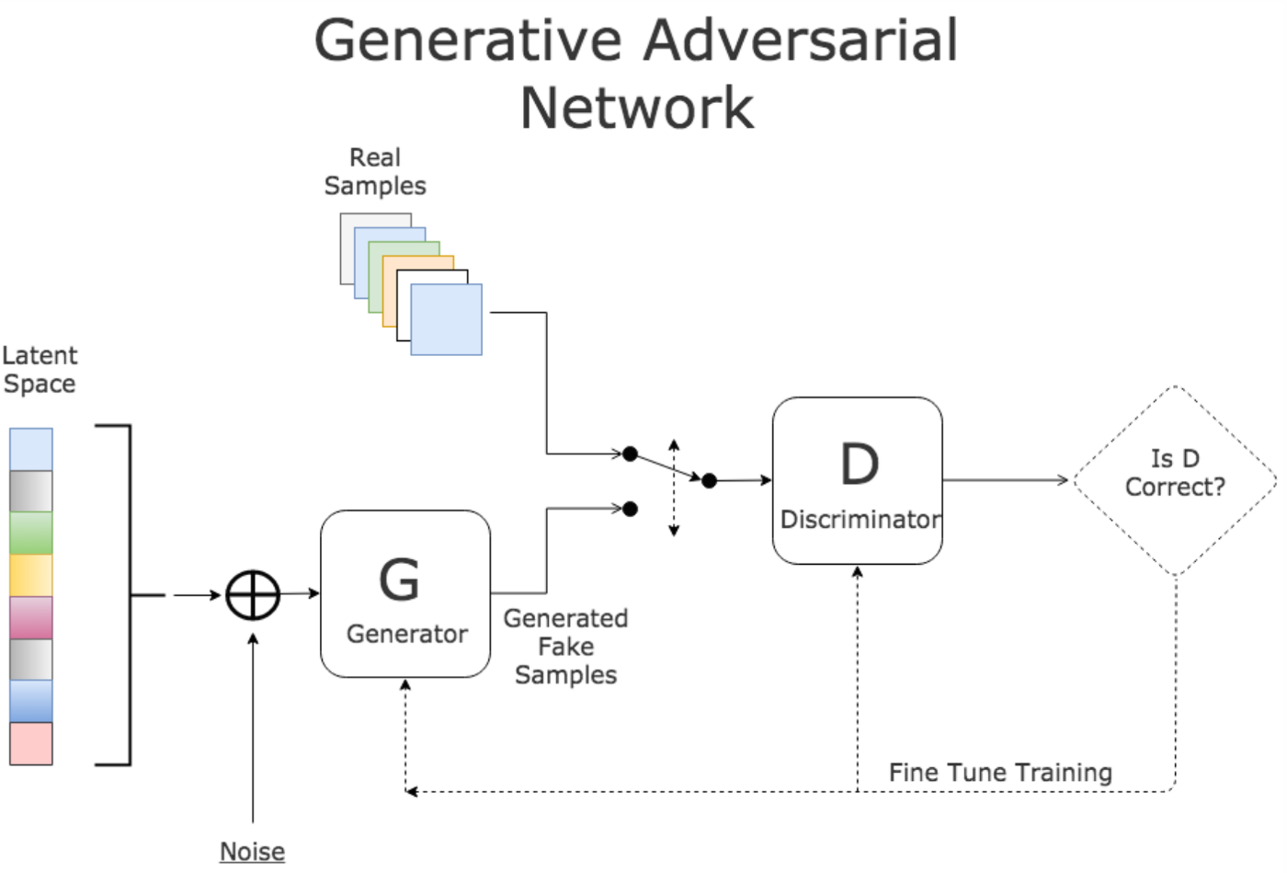

Mode Collapse: One of the biggest challenges in training GANs is mode collapse, which occurs when the generator network produces only a limited number of distinct outputs rather than a diverse set of outputs.​

Instability: GANs can be difficult to train because they are highly sensitive to the initial conditions and the choice of hyperparameters.​

Convergence: GANs can be difficult to train to convergence, meaning that the generator and discriminator networks may never reach an optimal solution.​

​ ​ ​ ​ ​ ​ ​

​ What are the difficulties with training GANs?​ ​

​ ​ ​ ​ ​ ​ ​

​ Discriminative vs Generative model​ ​

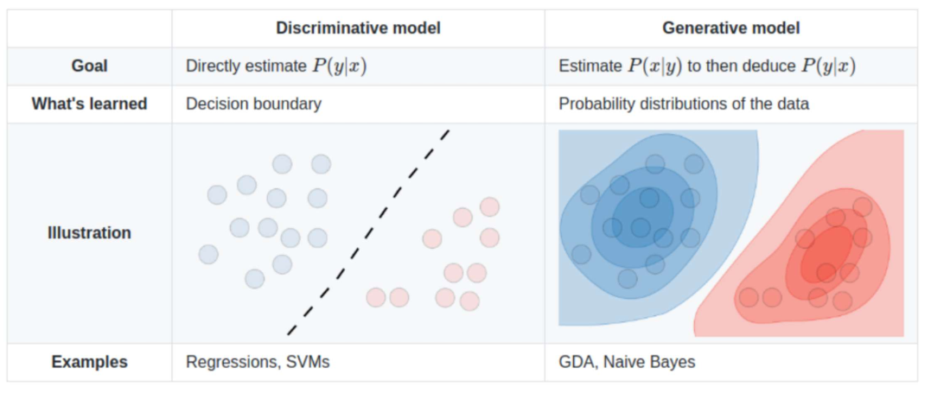

​ ​ What is Generative loss?​ ​ ​

​ ​The generative loss in GANs is a scalar value that represents the discrepancy between the generated samples and the real data. The goal of the generator is to minimize this loss so that the generated samples become as similar as possible to the real data.​

Loss = -(1/m) ∑[y log(p) + (1-y) log(1-p)]​

where:

m is the number of samples,

y is the true label (0 or 1), and

p is the predicted probability of the positive class (real image).

The exact form of the generative loss will depend on the specific problem being solved and the type of data being generated, but these examples should give you a good idea of what a generative loss function might look like.​

​ What is Discriminative loss?​ ​

One common example of a discriminative loss function is binary cross-entropy loss, which is defined as:​

Loss = -[y * log(D(x)) + (1 - y) * log(1 - D(x))]​

Where:​

D(x) is the output of the discriminator for input x (the generated or real data sample).​

y is the label indicating whether x is real (y = 1) or generated (y = 0).​

The binary cross-entropy loss measures the discrepancy between the predicted probability (D(x)) and the true label (y).​ ​ ​ ​ ​ ​ ​

CycleGAN: CycleGAN is a GAN that is used for image-to-image translation, where the goal is to transform an image from one domain to another, such as converting a horse into a zebra, or a photograph into a painting. The network is trained on a dataset of paired images and learns to map an image from one domain to the other and back again.​ ​ ​ ​ ​ ​ ​ ​ ​ ​ ​ ​ ​ ​​ ​

GANs applications example - 1

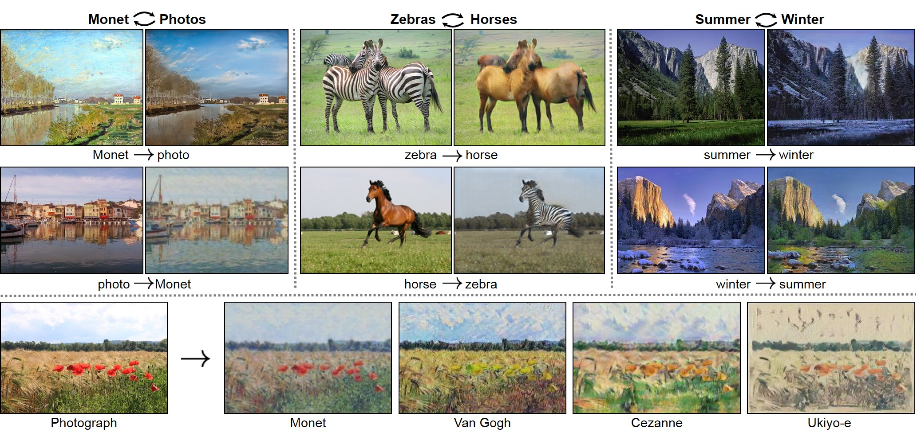

**​Image Generation:** GANs can be used to generate realistic images in various domains such as faces, objects, scenes, and so on.​

**Image Translation:** GANs can be used to translate images from one domain to another, such as converting grayscale images to colored images or translating photographs into paintings.​

**Data Augmentation:** GANs can be used to generate additional training data for deep learning models, which can help to improve the model's performance and reduce overfitting.​

**Text Generation:** GANs can be used to generate text, such as writing new articles, composing poems, or even coding new programs.​

**Video Generation:** GANs can be used to generate videos that are similar to real videos. ​ ​

Application of GANs

​ ​ Simple working of GANs​ ​ ​

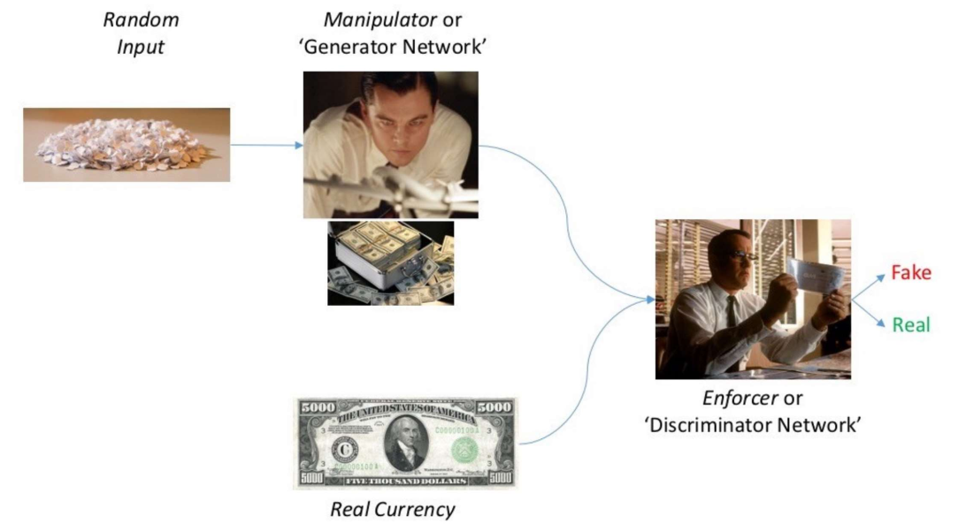

GANs applications example - 2

SRGAN is a Generative Adversarial Network used for single image super-resolution. It increases the resolution of an image, making it appear clearer and more detailed. The network is trained on a large dataset of high-resolution images and learns to generate a higher resolution version of a given low-resolution input.​ ​ ​ ​ ​ ​ ​ ​ ​ ​ ​ ​ ​

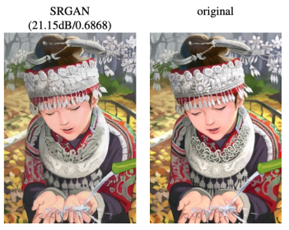

​ StyleGAN: StyleGAN is a Generative Adversarial Network (GAN) used for synthesizing new images of human faces that are highly realistic and diverse. It can generate high-quality, diverse images with different styles, poses, and facial expressions, based on a large dataset of real faces.​ ​

​ ​ ​ ​ ​ ​ ​ ​ ​ ​ ​

​ ​ ​ ​ ​ ​ ​

​ ​ GANs applications example - 3​ ​ ​​

